Unit Load Containers | Interchangeability | Usable Volume | Max. net  weight capacity | IATA code: | IATA rate  class | Dry ice  Capacity
LD-3 Container  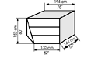 | 74F / D1F / 743 / 767 / 777 / M 11 / 330 / 340 / truck  Loadable on 767 instead of 2 LD2 units | 4.2 m3 /  148 cu. ft | 1,500 kg/  3,307 lbs | AVE,  AKE,  XKG,  XKN | 8 | -
LD-2 Container  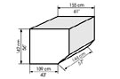 | 767 /  777 /  truck | 3.4 m3 /  120 cu. ft | 1162 kg/  2561 lbs | DPE | 8 | -
LD-8 Container  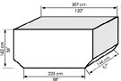 | 767 /  777 /  truck | 7,2 m3 /  253 cu. ft | 2342 kg/  5163 lbs | ALE | 6 | -
LD-9 Envirotainer cooltainer  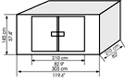 | 74F / D1F / 743 / 767 / 777 / M 11 / 330 / 340 / truck | 8.3 m3 /  293 cu. ft | 5,588 kg/  12,319 lbs | RAP | 5 | 300 kg
LD-3 Envirotainer cooltainer  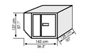 | 74F / D1F / 743 / 767 / 777 / M 11 / 330 / 340 / truck  Loadable on 767 instead of 2 LD2 units | 3.1 m3 /  109 cu. ft | 1,331 kg/  2,934 lbs | RKN | 8 | 180 kg
LD3-45 Container  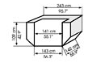 | A319 /  A320 /  A321 /truck | 3.5 m3 /  124 cu. ft | 1,052 kg/  2,323 lbs | AKH  DKH | Not available | -
Weights depend on the structural weight limitations of the different pallet /container positions in the aircraft. Container sizes may vary depending on Carrier equipment.

